KAMPALA JUNIOR ACADEMY
HOLIDAY WORK SET THREE TERM I 2020
PRIMARY ONE
ENGLISH

My name is ________________________________________________
Class ______________________________________________________

1. Name the pictures.
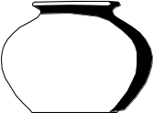 |  | 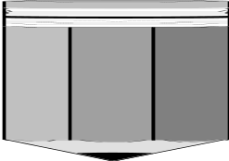 | 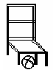

2. Write these words in capital letters.
(a) apple _________________
(b) dog __________________
(c) bursar __________________

3. Write a short word from the long word.
(a) office _______________________
(b) afternoon _____________________
(c) pigeon _____________________

4. What are these?
(a) These are ___________________
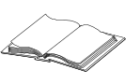
(b) _____________________________________

(c) _____________________________________
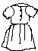
(d) ______________________________________

5. Underline the noun in each sentence.
(a) My name is Faith.
(b) Today is Monday.
(c) The cup is dirty.
(d) I am going to Kampala.

6. Use “a” or “an” to fill the gaps.
(a) This is _________ flower.
(b) Here is _________ orange.
(c) _________ owl has big eyes.

7. Write these sentences correctly.
- is This drum a
___________________________________________________
- can a I see cow.
___________________________________________________

8. Fill in the gaps with: in, on, under, near
 (a) The cup is _________ the chair.
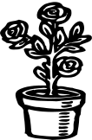
(b) The flower is ________ the vase.

(c) The cat is __________ the tin.

(d) The snake is ___________ the bed.

9. Match the opposites
(a) old bad
(b) tall small
(c) good new
(d) big short

10. Underline the odd word out.
A | B | C
bursar | Nurse | ear
teacher | mother | leg
cook | Father | eye
doctor | Sister | dress


11. Complete correctly.
(a) This is a leg. These are ____________.

(b) This is an _________. These are eggs.

(c) This is a ____________. These are pencils.

(d) This is a chair. These are __________.

12. Fill in the gaps with “has” or “have”
- We ______________ a yellow bus.
- Mary ______________ a nice dress.
- _____________ he come to school today?
- I _____________ four oranges.


13. Count and write in words.
(a) _______________ flowers.


(b) _______________ balls.

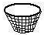
(c) _______________ baskets.

(d) _______________ huts.

14. Fill in the correct word.

(a) He is _______________ in his book. cooking

(b) She is _______________ the floor. riding

(c) He is _______________ a bicycle. writing

(d) He is _______________ food. mopping

END

